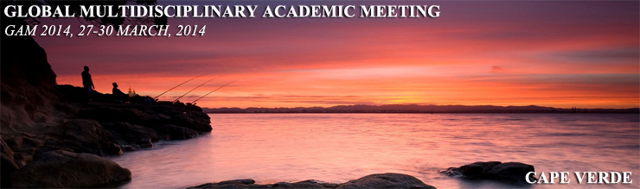
Call for Papers !!!
1st Global Multidisciplinary Academic Meeting, GAM 2014
"Science does NOT know borders"
University of Santiago, Cape Verde 27-30 March 2014
SUBMISSION DEADLINE: 15 February, 2014

Keynote speakers:
Dr. Martin Beniston
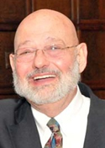Dr. Edward A. Gotfried
Distinguished Researchers,
We have the pleasure of inviting you to submit your scientific work for the 1st Global Multydisciplinary Academic Meeting , GAM 2014which will be held at the University of Santiago at the magnificent Cape Verde Islands.
GAM 2014 will gather researchers from universities, companies and government executives from all around the globe. The participants will present their scientific attainments in various academic disciplines. Leading by the motto “Science does NOT know borders” the event will connect different cultures and attitudes thus contributing to: knowledge transfer, sharing best practices and research skills improvement.
All accepted papers will be published as a special publication with an unique ISBN number. The authors will be also sent a printed copy of the publication after the conference finishes.
The papers will be also published in a special edition of one of the most progressive international scientific journals in South Europe, The European Scientific Journal (ESJ).
Supported the concept of interdisciplinarity papers in all academic areas are welcomed. The accepted papers will be presented in a parallel sessions.
The authors of the accepted papers are not obliged to present their works. "Only publishing" option is available.
GAM 2014 is a joint summit event organized by: European Scientific Institute (ESI), University of Santiago, Cape Verde, the University The Azores, Portugal and the Center for Law and Economic Studies. Along the quality scientific schedule, great social programme for the participants will be provided.
VISA/Travel
The state of Cape Verde has quite simple and fast visa procedure. All visitors entering Cape Verde require a visa on arrival (cost: 40 euros) You can get visa application on:
http://cape-verde.travisa.com/PDFFiles/cape_verde_dc_visa.pdf.You need One signed Cape
We are expecting you in Cape Verde.
Sincerely,
European Scientific Institute, ESI
University of Santiago, Cape Verde
University of the Azores, Portugal
Center for Law and Economic Studies

