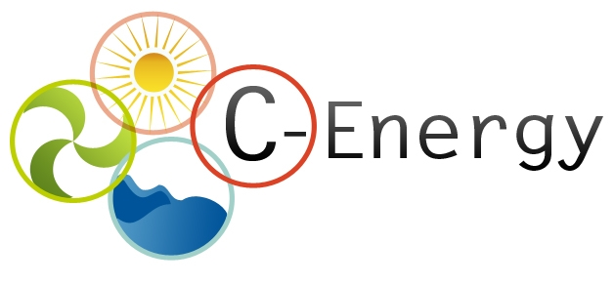

Partnering offer
Date (DD-MM-YY)

- (*) Description of the expertise offered (up to 1000 characters)
A Spanish technology centre is looking for partners for submitting a proposal for the next H2020 call EE182014/15 “New technologies for utilization of heat recovery in large industrial systems, considering the whole energy cycle from the heat production to the delivery and end use”. The aim of the proposal is the development of new technologies integration in heat recovery in industrial processes. SMEs with expertise in gas treatment with capabilities within this field and heat recovery in steam boilers, burners, engines is sought.
An expert on gas cleaning and removal of impurities of Si and P is needed to evaluate the gas treatment systems available so determine the best option for gas cleaning and collaborate in the integration in the whole process. It is also desirable a partner with expertise in heat recovery and use systems. As before, it will be involved in integration tasks.

- Keywords describing the expertise offered (up to 10 words)
Gas cleaning
Hear Recovery
Steam boilers
- (*) Relevant topic in work programme
H2020 EE182014/15 “New technologies for utilization of heat recovery in large industrial systems, considering the whole energy cycle from the heat production to the delivery and end use”.

- Former participation in FP or other international cooperation projects

Organisation information

Organisation and country:
Foundation CIDAUT (Spain)
Type of organisation:
□ Enterprise □ SME □ Academic xResearch institute □ Public Body □ Other:
Former participation in FP European projects?
□ Yes □ No
Web address:
www.cidaut.es
Description of the organisation:

(*) Contact details

Contact person name | Luis Nieto / Henar Olmedo
Telephone | +34 983548035
E-mail | luinie@cidaut.es/ marolm@cidaut.es
Country | Spain

(*) -Mandatory

