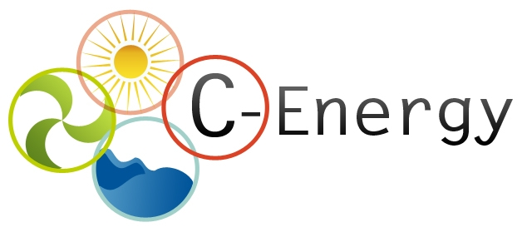

Partnering offer
Date (DD-MM-YY)

- (*) Description of the expertise offered (up to 1000 characters)
Smart Meters - From 2009, an innovative campaign using Smart Meters to monitor domestic saving has been implemented - real-time electricity consumption metering. A coaching process to over 125 voluntary’ families has achieved an average of 13,1% electricity saving. This initiative was selected by the Covenant of Mayors as a successful example and was selected as Nominees at ManagEnergy Local Energy Action Award 2011 - website [in catalan]: http://ca.sabadell.cat/Energia/p/comptadors_cat.asp

Smart District – Currently participating in District of the Future [FP7 funded project] up to November 2016. DoF will use ICT to collect, register and monitor energy data and bring this to a cloud-based software platform. This platform will analyze energy patterns in three cities (Corby, Sabadell and Orleans), allowing predicting energy consumption and energy production behaviour in each district.

Our key interests are among these:
- Final-users access to data from utilities' smart meters.
- Smart meters use for saving [domestic and small consumers]
- Smart meters for energy poverty reduction
- Implementation of IT energy tools for energy poverty abatement

- Keywords describing the expertise offered (up to 10 words)
Smart meters, monitoring, coaching, energy poverty, vulnerable consumers, education, software, IT tools.

- (*) Relevant topic in work programme
EE10 - Consumer Engagement for Sustainable Energy.

- Former participation in FP or other international cooperation projects
FP7.
Intelligent Energy Europe.
Leonardo Programme.
FEDER
LIFE.

Organisation information

Organisation and country:
Sabadell Municipality, Spain.
Type of organisation:
□ Enterprise □ SME □ Academic □Research institute X Public Body □ Other:
Former participation in FP European projects?
X Yes □ No
Web address:
http://www.sabadell.cat/ca/smartcity
Description of the organisation:
Sabadell City Council [208.000 inhabitants] located in the Barcelona Metropolitan Region and
benefiting from a strategic position in southern Europe, close to a world city like Barcelona, well connected to main infrastructures linking the Mediterranean coast to the rest of Europe.

The city is completely committed to the “Sabadell Smart City” strategy and is working intensively for its implementation. Currently 34 projects have been designed under a crosswide strategy involving all public departments and 27 external stakeholders.
The external main actors involved in the projects catalogue definition have been grouped in a partnership which meets quarterly to provide technical assessment to the projects developed. Sabadell is participating in different key international and national networks such as:
• COVENANT OF MAYORS
• SPANISH NETWORK FOR SMART CITIES (RECI)
• AENOR STANDARDIZATION COMMITTEE FOR SMART CITIES
• CITY PROTOCOL SOCIETY
• EUROPEAN CIVITAS FORUM and CIVINET Spain & Portugal

Also, recognition are basic requirements for the strategy to succeed, highlighting the following funds and prizes achieved:
• World Smart City Awards 2013, final runners at the City Category.
• Civitas Award 2013, final runners at the Technical Innovation Category.
• Access City Award 2013, semifinal runners.
• WeGo Prize 2012, winner to best e-government.
• SEMS-2011 Prize (Spanish Sustainable Mobility Week), final runners
• ManagEnergy Local Energy Action Award 2011, category “Awareness and information projects” (Nominees)
• Green Building 2010 National Prize, “Most innovative project”

(*) Contact details

Contact person name | Mr. Jaume Enciso
Telephone | +34 937 453 314
E-mail | oficinaenergia@ajsabadell.cat
Country | Spain

(*) -Mandatory

