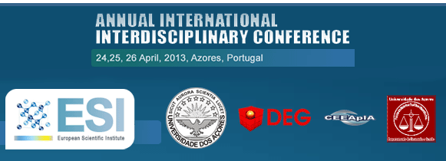

Call for Papers
AIIC 2013, Annual International Interdisciplinary Conference,
Azores Islands, Portugal 24,25,26 April 2013

SUBMISSION DEADLINE: 10th of APRIL 2013

Distinguished Colleagues,
We have the pleasure of inviting you to submit your scientific work for
the AIIC (Annual International Interdisciplinary Conference), 24,25 and 26
April 2013, Azores Island, Portugal.
http://aiiconference.net/index.php/en/pa-2
All accepted papers will be published as a special publication with an
ISBN number. The author will be sent a printed copy of the publication
after the conference finishes.

The papers will be also published in a special edition in of one of the most influential scientific journals in South Europe, the European Scientific Journal (ESJ).

Authors that will not be personally present on the event will be given the
opportunity, on their request, to make an online presentation for the
conference participants.

The authors are not obliged to present their works (personally or online).
AIIC is organized by: European Scientific Institute, University of The
Azores and its partners.
Supporting the concept of interdisciplinarity we welcome submissions in
all academic fields.

Sincerely,

European Scientific Institute
University of The Azores
---------------------------------
For any other information please send us e-mail on:
contact@aiiconference.net
Website: www.aiiconference.net
http://www.aiiconference.net/index.php/en/

