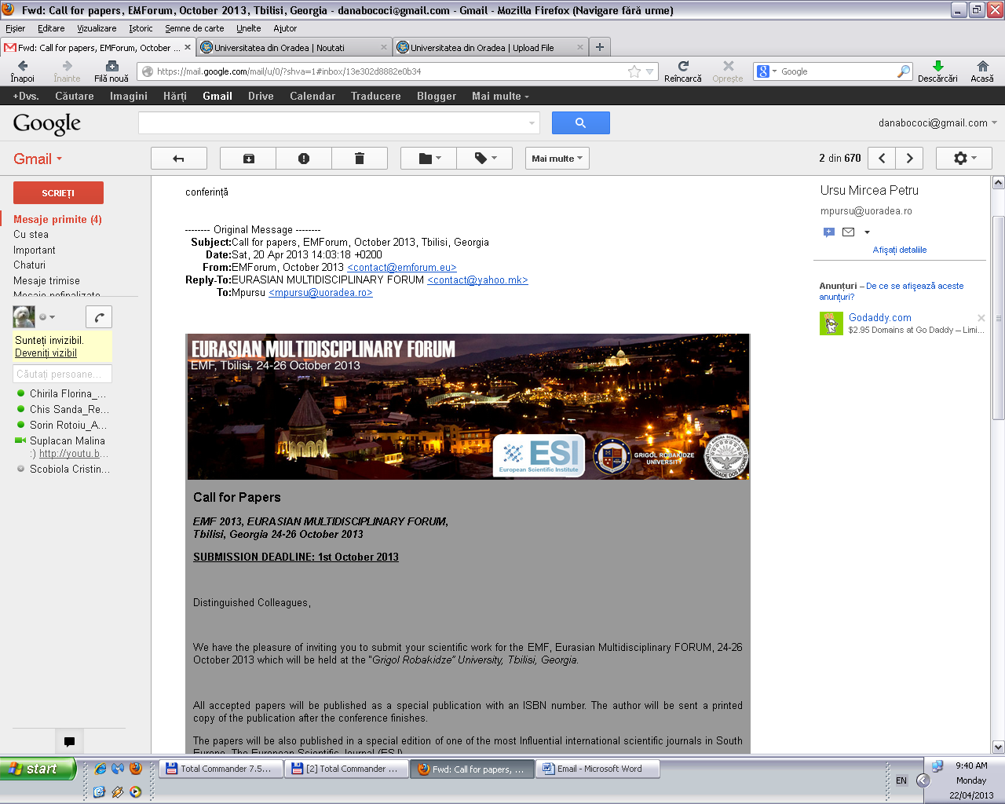
Call for Papers
EMF 2013, EURASIAN MULTIDISCIPLINARY FORUM,
Tbilisi, Georgia 24-26 October 2013
SUBMISSION DEADLINE: 1st October 2013

Distinguished Colleagues,

We have the pleasure of inviting you to submit your scientific work for the EMF, Eurasian Multidisciplinary FORUM, 24-26 October 2013 which will be held at the “Grigol Robakidze” University, Tbilisi, Georgia.
All accepted papers will be published as a special publication with an ISBN number. The author will be sent a printed copy of the publication after the conference finishes.
The papers will be also published in a special edition of one of the most Influential international scientific journals in South Europe, The European Scientific Journal (ESJ).
Authors of the accepted papers that will not be personally present on the event will be given the opportunity, on their request, to make an online presentation for the conference participants.
The authors are not obliged to present their works (personally or online).
EMF 2012 is organized by: European Scientific Institute, “Grigol Robakidze” University and the University of The Azores, Portugal.

Supporting the concept of interdisciplinarity we welcome submissions in all academic fields.
Sincerely,
European Scientific Institute
“Grigol Robakidze” University
University of The Azores
---------------------------------
For any other information please send us e-mail on:
contact@emforum.eu
Website: www.emforum.eu
http://emforum.eu/

