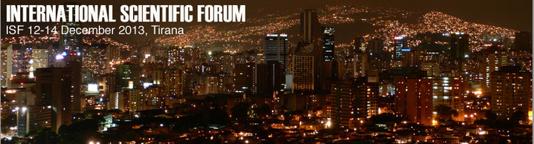
Call for Papers

ISF 2013, INTERNATIONAL SCIENTIFIC FORUM,
Tirana, Albania 12-14 December 2013

SUBMISSION DEADLINE: 30th November 2013

Distinguished Colleagues,

We have the pleasure of inviting you to submit your scientific work for the ISF, INTERNATIONAL SCIENTIFIC FORUM, 12-14 December 2013 which will be held at the “Vitrina” University, Tirana, Albania.

All accepted papers will be published as a special publication with an ISBN number. The author will be sent a printed copy of the publication after the conference finishes.
The papers will be also published in a special edition of one of the most Influential international scientific journals in South Europe, The European Scientific Journal (ESJ).

Authors of the accepted papers that will not be personally present on the event will be given the opportunity, on their request, to make an online presentation for the conference participants.

The authors of the accepted papers are not obliged to present their works (personally or online).

ISF 2013 joint summit event organized by: European Scientific Institute, “Vitrina” University and the University of The Azores.

Supporting the concept of interdisciplinarity we welcome submissions in all academic fields.

Sincerely,

European Scientific Institute
Vitrina University, Albania
University of The Azores, Portugal
---------------------------------
For any other information please send us e-mail on:

contact@isforum.us
Website: www.isforum.us
http://isforum.us/

